Wyoming Snapshot Day 2016

Tuesday, October 11, 2016 is Wyoming Snapshot Day. Snapshot Day is a chance to celebrate libraries and how they support lifelong learning. Participation in Snapshot Day includes sending pictures to the state library of students and staff enjoying the Burns High School library.

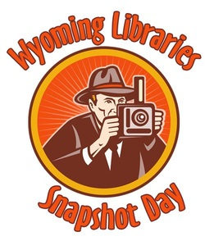
If your young person would like to participate in Snapshot Day, please sign and return the form below no later than Friday, October 7, 2016 to give permission for photographs to be taken of your child and submitted to the Wyoming State Library. The photos will be placed on social media websites such as Flickr, Facebook, and other applications chosen by the Wyoming State Library. You can view photos from last year’s Snapshot Day by visiting:
http://wyomingsnapshot.weebly.com

Also, the photos will be placed in a stock photo collection for use by the Wyoming State Library. Students’ names will not be submitted with their images.

For more details on Wyoming Snapshot Day, please visit: http://wyomingsnapshot.weebly.com/.

Thank you for supporting your child in making this year’s Wyoming Snapshot Day an exciting and fun statewide event.

Sincerely,

[NAME]
[LIBRARY]

I give my permission for ________________________________ to be photographed on Wyoming Snapshot Day 2016. I understand that these photos will be used by the Wyoming State Library for library promotion and advocacy and will be placed on social media and other websites on the World Wide Web. I also understand that my child’s name will not be connected with his or her picture.

Signature_________________________________________ Date________________________

